Case 5-Asia-China-Roof Tile-Dragon-Dai Qing



The **Azure Dragon** (青龍 *Qīnglóng*) is one of the [Four Symbols](https://en.wikipedia.org/wiki/Four_Symbols_(Chinese_constellation)) of the [Chinese constellations](https://en.wikipedia.org/wiki/Chinese_constellations), which are the astral representations of the Wufang Shangdi. represents the [east](https://en.wikipedia.org/wiki/East) and the [spring](https://en.wikipedia.org/wiki/Spring_(season)) season.[[1]](https://en.wikipedia.org/wiki/Azure_Dragon#cite_note-FOOTNOTETom198955-1) chasing a flaming pearl among clouds

As the other three Symbols, there are seven "mansions", or positions, of the [moon](https://en.wikipedia.org/wiki/Moon) within Azure Dragon. The names and determinative stars are:[[3]](https://en.wikipedia.org/wiki/Azure_Dragon#cite_note-3)[[4]](https://en.wikipedia.org/wiki/Azure_Dragon#cite_note-4)

|  |  |  |  |
| --- | --- | --- | --- |
| **Mansion no.** | **Name (pinyin)** | **Translation** | **Determinative star** |
| 1 | 角 (Jiăo) | [Horn](https://en.wikipedia.org/wiki/Horn_(Chinese_constellation)) | [Spica](https://en.wikipedia.org/wiki/Spica) |
| 2 | 亢 (Kàng) | [Neck](https://en.wikipedia.org/wiki/Neck_(Chinese_constellation)) | [κ Vir](https://en.wikipedia.org/wiki/Kappa_Virginis) |
| 3 | 氐 (Dĭ) | [Root](https://en.wikipedia.org/wiki/Root_(Chinese_constellation)) | [α Lib](https://en.wikipedia.org/wiki/Alpha_Librae) |
| 4 | 房 (Fáng) | [Room](https://en.wikipedia.org/wiki/Room_(Chinese_constellation)) | [π Sco](https://en.wikipedia.org/wiki/Pi_Scorpii) |
| 5 | 心 (Xīn) | [Heart](https://en.wikipedia.org/wiki/Heart_(Chinese_constellation)) | [Antares](https://en.wikipedia.org/wiki/Antares) |
| 6 | 尾 (Wěi) | [Tail](https://en.wikipedia.org/wiki/Tail_(Chinese_constellation)) | [μ Sco](https://en.wikipedia.org/wiki/Mu_Scorpii) |
| 7 | 箕 (Jī) | [Winnowing Basket](https://en.wikipedia.org/wiki/Winnowing_Basket_(Chinese_constellation)) | [γ Sgr](https://en.wikipedia.org/wiki/Gamma_Sagittarii) |

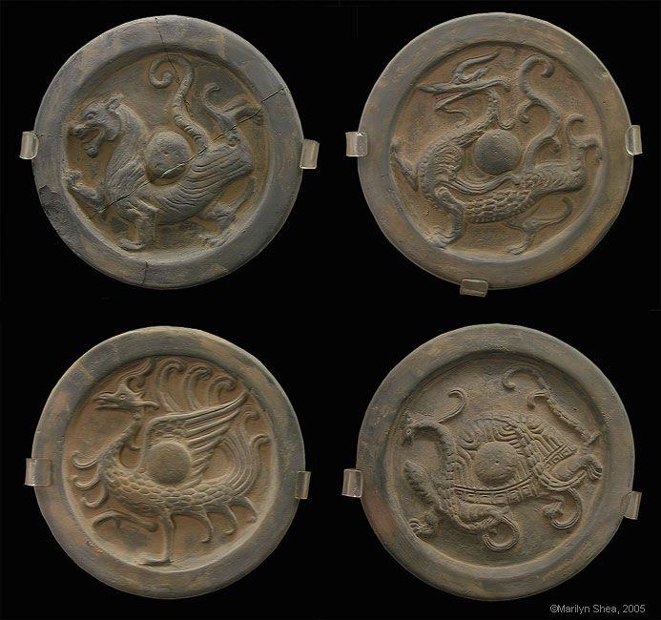

Roof Tiles of the Chinese Zodiac Constellations replicas of roof tiles at the Ancient Observatory in Beijing are from the Ming Dynasty and depict the Azure Dragon, the Black Turtle, the Vermillion Bird, and the White Tiger. After http://hua.umf.maine.edu/China/astronomy/tianpage/0027H_constellations539 These